**Using Copilot in MS WORD 365**

Word with the Copilot function shown in the menu. A paragraph of text has been typed in for this demonstration.

Click or tap 

The editor side panel has the following:

* Editor Score
* Formal writing
* Correctios
* Refinements
* Similarity
* Insights

This appears in your Word Window as shown below:

Click or tap each to activate. The results are presented below:

**Editor Score**

**Formal writing**

In this demonstration it is set to Casual

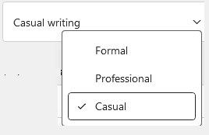

**Corrections**

The spelling and grammar are corrected in the document. Spelling errors are marked in red, grammar errors in blue.

In the Editor panel the number of occurrences is shown:

**Refinements**

The author’s example appears to be, OK? Imagine that.

**Similarity**

The process took about 10 minutes. A message that it was checking displayed until this one appeared. The author did not expect an answer. See below for an example that should work.

**Insights**

Clicking or tapping the Document Stats box produces:

In the WORD document menu clicking  produces the following:

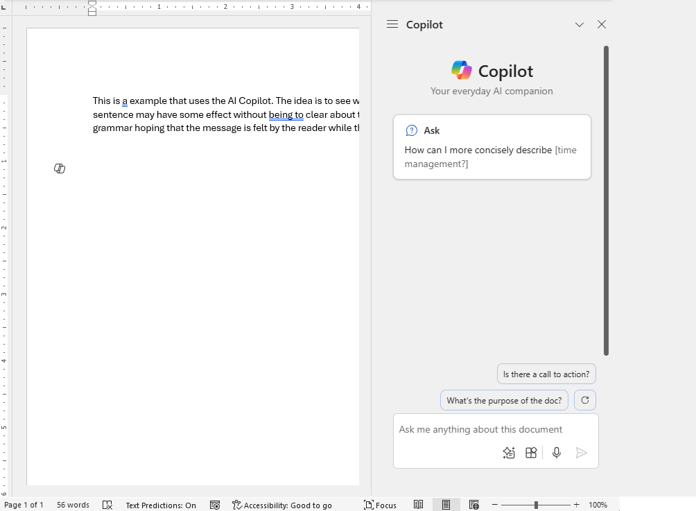

Click on this.

Put this suggested question into the question box:

This is the answer:

The following is an example of Copilot where the author asks for a Similarity check. First, the text to be checked, followed by copilot’s answer.

Response:

The first paragraph was underlined. When I clicked that, copilot provided this explanation.

An example of help from copilot. The first sentence I this document has “been typed” underscored. Click on this to see copilot’s response.

Copilot brings up a work box shown below:

